Designing cross-platform experiences

When designing a new product or feature, it’s important to think about the different types of platforms that the design will be experienced on. As a refresher, a **platform** is the medium that users experience your product on. Some common platforms are:

* Desktop computers
* Laptop computers
* Mobile phones
* Tablets
* Wearables, like smart watches
* TVs
* Smart displays

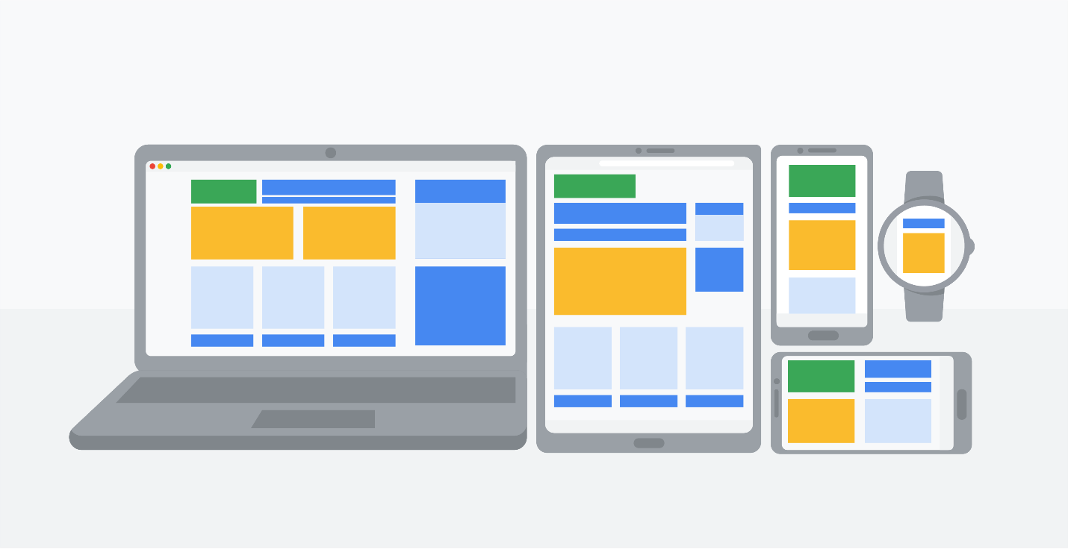

A product might be experienced on countless different platforms, but desktop computers, laptop computers, and mobile phones are the most commonly used platforms for interacting with apps and websites. These are the platforms that you'll spend the most time focusing on during this certificate program. In this reading, you'll learn about key considerations when designing for different platforms to help you get started.

**Screen size**

The first consideration when designing for various platforms is adjusting design elements and features to fit different screen sizes. For example, you have a lot of screen space when you design for desktop and laptop computers. But when you design for smaller screens, like mobile phones, you have to carefully decide which parts of the design you'll prioritize including in the limited space. This means making every word, icon, and image count!

In the first five courses of this certificate program, you will design an app for a mobile phone. In the sixth course of the program, you will design a responsive website, which allows the design of a website to change automatically depending on the device's screen size. This means you'll learn a lot more about designing for different screen sizes later in the certificate program, so stay tuned.

**Interaction**

In addition to the size of the screen, you also need to consider the way users interact with each platform and how those interactions might affect your design decisions.

It’s also critical to consider accessibility when developing your designs at each point. Different groups of people will interact with your product in different ways, like using a screen reader, closed captioning, or a switch device. To get started, it’s helpful to try using some of these technologies yourself, in order to understand how people with disabilities might interact with your product on different platforms.

**Content layout**

In the world of UX design, layouts refer to the way that information is organized on the screen. For example, when designing for desktop or laptop computers, you have the advantage of working with a familiar, standardized size: landscape (horizontal) mode. The screen is wide, content can be laid out in columns, and there’s much more flexibility to design.

In contrast, mobile phone content is usually laid out in portrait (vertical) mode, which is ideal for scrolling. In addition, mobile phones often allow users the option to use landscape (horizontal) mode by rotating their device. Implementing this in your designs requires more work from you as a designer, but provides users with a wider range of options.

Consider the layout of content on a couple more platforms: tablets combine both the desktop and mobile phone user experience, which means you can incorporate aspects of desktop and mobile phone content layouts in your designs. Smartwatches tend to have compact square or rectangular screens, offering very little digital real estate to lay out content.

**Functionality**

There are a lot of reasons why users might choose one platform over another, but functionality and the kind of tasks they want to complete is a huge driver. Your designs for each platform will likely vary based on how and when you expect users to need the product.

Optional - Learn more about design sprints

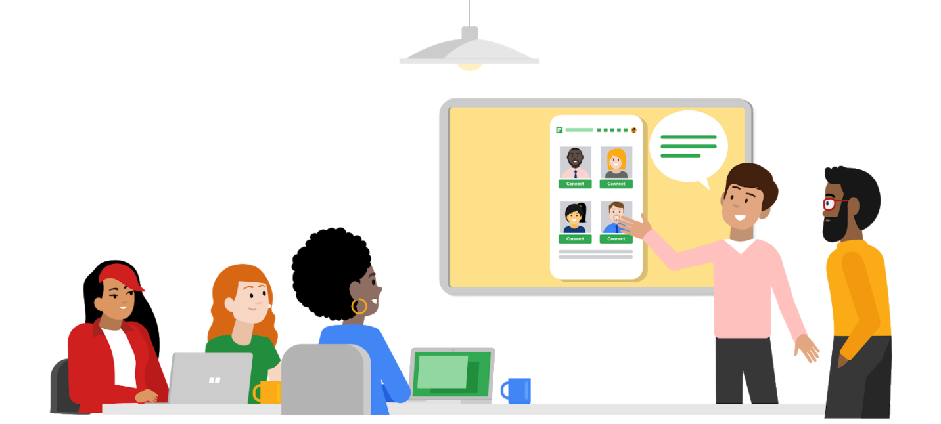

If you’re looking for a deeper dive into design sprints, why not take it up with the source? The Google [Design Sprint Kit](https://designsprintkit.withgoogle.com/) is an open-source resource for anyone who is learning about or running design sprints. The website includes [case studies](https://designsprintkit.withgoogle.com/case-studies) about design sprints that have solved all kinds of challenges, [templates for decks and activities](https://designsprintkit.withgoogle.com/resources/overview), and more.

In addition, check out this [article on Medium about the importance of design sprints](https://uxplanet.org/whats-a-design-sprint-and-why-is-it-important-f7b826651e09#:~:text=A%20Design%20Sprint%20is%20a,and%20testing%20ideas%20with%20customers.). Or, to be really inspired, read the book [Sprint](https://www.thesprintbook.com/book) by the creator of design sprints, and former Googler, Jake Knapp. Pay special attention to the chapters “Start at the End” to get an overview of how to establish long-term goals for a sprint, and “Liftoff” to motivate you to get started with your first sprint. Happy reading!

**An entry-level designer’s role**

If you’re just starting out as a UX designer, you might also be curious to learn about an entry-level UX designer’s role in a sprint. We’ve got the inside scoop for you! Check out this post from the INKONIQ BLOG about [how a design sprint works at Google](https://medium.com/inkoniq-blog/inside-a-design-sprint-workshop-at-google-3950b1654f2) and this article on Medium about what [one UX designer learned from their very first design sprint](https://uxplanet.org/3-things-i-learned-from-my-first-design-sprint-ed5d2113afad).

Congratulations on getting the hang of all things design sprints! Use these resources as you continue to explore the stages and purpose of this key part of UX design work.